

SANJAY GHODAWAT UNIVERSITY

## Kolhapur

Established under section 2(f) of UGC Act 1956

Sanjay Ghodawat University Act XL of 2017 of Govt. Maharashtra Approved by PCI, COA & AICTE

# PROJECT SYNOPSIS

**On**

# “Live Search Weather Web Application”

A synopsis submitted in partial fulfillment of the requirements for the School of Computer Science and Engineering

By

# Samarth Mali 21ST114282014

**Yash Suryawanshi 21ST114282036**

# Shubham Chougule 21ST114282039

**Sumit Kamble 21ST114282045**

Program: Bachelor of Computer Science and Engineering Class: FY B. Tech

Under Supervision of

## Ms. Prajakta Sakhare

Assistant Professor

School of Computer Science and Engineering

A.Y 2022-23



# SANJAY GHODAWAT UNIVERSITY

## Kolhapur

Established under section 2(f) of UGC Act 1956

Sanjay Ghodawat University Act XL of 2017 of Govt. Maharashtra Approved by PCI, COA & AICTE

**School of Computer Science and Engineering**

# CERTIFICATE

**PROJECT SYNOPSIS**

**On**

# “Live Search Weather Application”

Submitted By

# Samarth Mali 21ST114282014

**Yash Suryawanshi 21ST114282036**

# Shubham Chougule 21ST114282039

**Sumit Kamble 21ST114282045**

Program: Bachelor of Computer Science and Engineering Class: FY B. Tech

Is work done by him/her and submitted during academic year 2022-23, in partial fulfillment of the Project Synopsis.

### Sanjay Ghodawat University, Kolhapur

**Ms. Prajakta Sakhare Dr. B. Suresh Kumar**

**Course coordinator HOS, SoCSE**

**INTRODUCTION**

The “Weather Webapp Using React JS And Weather API” is very users friendly it is design to help user to access Weather of different place all over the world on the screen. This webapp is made using React JS and Weather API because it runs on local host, and it is very user friendly, and it does not consume more memory. This webapp can be run on limited data and it can be run many old devices it does not take lot of time to load. To make this application, we need an API (Application Programming Interface) which will provide the data you need to create a weather web application. For the current project, we will use an API to retrieve weather data in the world. Some APIs can be used for free, while some APIs must be paid for a certain price.

To create a weather web application, we will use the API from OpenWeatherMap.org which you can use for free or paid. To use this API, you need an API key. To get the API key, you must register with the Open Weather. Map web first. So please log in/sign up to <https://api.openweathermap.org>. then later we will use React JS.

## OBJECTIVES

* **Convenience:** The primary objective of the system is to provide a convenient and user-friendly platform for user to check the live weather details online. User can check weather result from anywhere, at any time.
* Accessibility: The system aims to make Live Weather Search Application accessible to a wider user. By providing an online platform, it allows people to see weather details in user friendly manner.
* Efficiency: The system aims to check live weather details via internet. It reduces efforts to check weather conditions via internet instead of watching live news for various areas.
* **Availability of Information:** The system provides comprehensive information about city, temperature, humidity, visibility, and wind speed. This allows users to make decisions about weather while leaving from home.

## EXISTING SYSTEM

Our “Live Search Weather Application” is a digital platform that allows user to see the weather for any city in the world over the internet. It provides a easy and convenient way for users to see weather forecast details in fancy GUI over the browser. Here are the key functions and features of our live search weather application:

1. **Humidity & Visibility:**

They are very critical parameters if the user plans to go on a long drive.

1. **Wind Speed and Intensity:**

Although the feature may not offer much help to the regular commuters. But it is a very valuable information paragliders, kite-surfers, sailors, and windsurfers.

1. **APIs Offering Accurate Weather Data:**

The API enables app developers to gather weather data of around 2,00,000 cities using 4,00,000 weather stations located around the world. It offers historical climate information spanning from one month to five years, data on air pollution, UV index.

1. **Temperature:**

This app is showing live temperature of searched city in details.

1. **Time & Date:**

This application is shows current date and time as per the geographical region.

## LIMITATIONS

* + **Technical Issues:**

Like any online platform, technical glitches, server downtime, or slow loading speeds can occur, leading to inconvenience for users. These issues may disrupt the weather API access or cause delays to fetch details for city.

* + **Limitation of Open API:**

10 queries per second (QPS) per IP address. In the API Console, there is a similar quota referred to as Requests per 100 seconds per user. By default, it is set to 100 requests per 100 seconds per user and can be adjusted to a maximum value of 1,000.

## PROPOSED SYSTEM

* + **Node JS:**

Node is the most popular platform for tools to make working with React easier. I think that's the case for 2 main reasons: Node ships with a reliable package manager (NPM) and it works with the NPM registry (hosted at npmjs.com).

will need a recent version of NodeJS to run create-react-app, as well as a recent version of Node Package Manager (npm).

* + **Visual Studio Code:**

For coding we have used Visual studio code (VS code), for our project we have used HTML, CSS, JAVASCRIPT, ReactJS which are a programming language that allowed us to create dynamic content that interact with API for accurate weather data fetches over the web application.

## TECHNOLOGY USED

### SOFTWARE REQUIREMENTS

* + - * Visual Studio Code
      * Node JS

### HARDWARE REQUIREMENTS

* + - * 4 GB RAM
      * 500 GB HDD
      * i3 processor

## METHODOLOGY

### Algorithm: -

1. Clone the source code from our private GitHub repository into our local system
2. Extract the ZIP file for source code where you want to save the code.
3. Once you extracted the ZIP file, go to folder path.
4. Open the Visual Studio Code and open that extracted folder.
5. It will show you all the project related files in that folder.
6. You need to install Node JS application on the local system.
7. Download the latest Node JS exe file from the Node JS official site.
8. Once you downloaded binary file, install it on the local system.
9. To verify the Node JS application by using command “node -v”.
10. In Visual Studio Code, open the new PowerShell terminal by pressing Ctrl + Shift + ~ keyboard key.
11. Now, you need to install NPM package install in that directory.
12. Navigate to exact folder and type “npm install” command in opened PowerShell terminal.
13. Now, we need to update our API key in the source code.
14. Navigate to Open API site https://api.openweathermap.org & then signup to get our API keys for free.
15. Once you signed up and get your API key, then update into “apiKeys.js” file which is located under “src” folder in line number 3 i.e., “key”
16. Once everything is set, then run “npm start” command in Power Shell terminal to run the application over the browser.
17. Now, we can browse our application.
18. Click on search box and search any city name that you want to check there live weather details.

## EXPECTED OUTCOMES

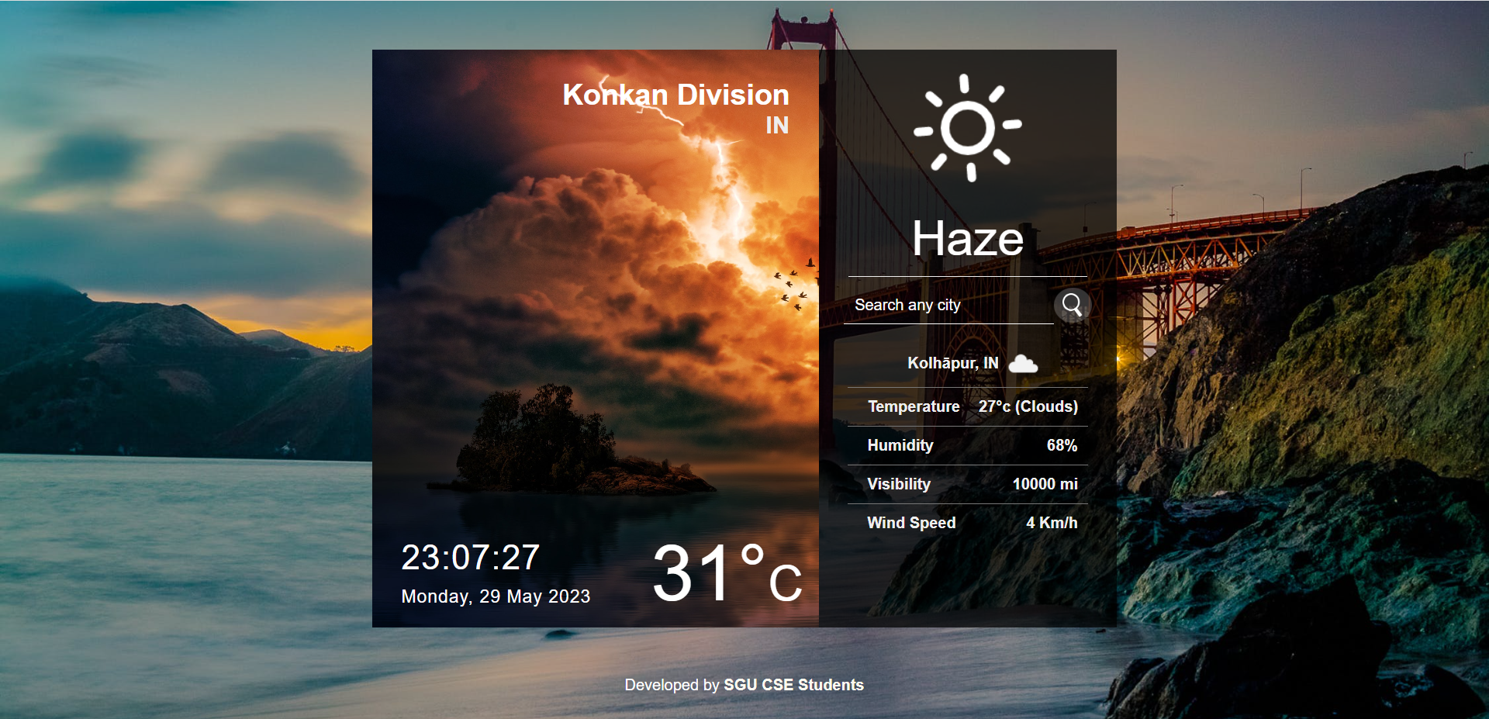

Fig 1. Web UI

## REFERENCES

* + <https://www.w3schools.com/>
  + [https://www.tutorialspoint.com/](https://www.tutorialspoint.com/php)
  + <https://www.wikipedia.org/>
  + <https://www.htmlhints.com/>